Worksheet:
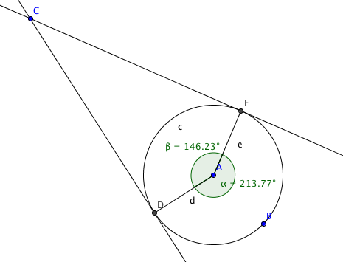
1. Find γ:

_________________________

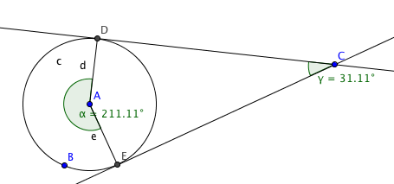
Find β:

____________________

