Courtney O’Day
Geogebra Lesson: Creating Two Tangents of a Circle to Form and Exterior Angle

1. We want to have a clear screen to see the circle, tangents and angles better so we will have to get rid of the axes. To do that, right click on the screen and click on Axes. That will give you a clear page.

2. Now we have to construct a circle so the center is A and the radius is B.
Click on the Circle with Center Through Point Tool, click anywhere, and move your mouse to make the size of the circle that you want.

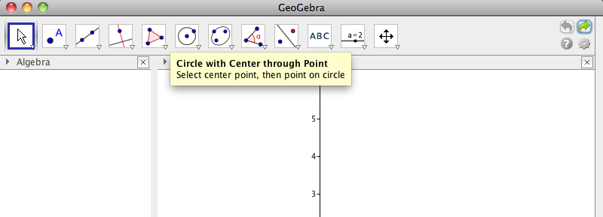

3. Construct a new point C outside of the circle.
Click on the Point Tool and place the point C anywhere you would like outside the circle.

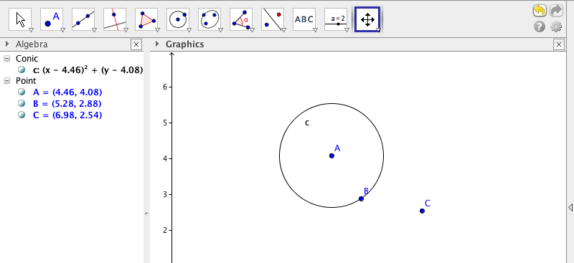

4. Tangents to the circle need to be constructed.
Click on the Tangents Tool. Next click point C and then click on the side of the circle.
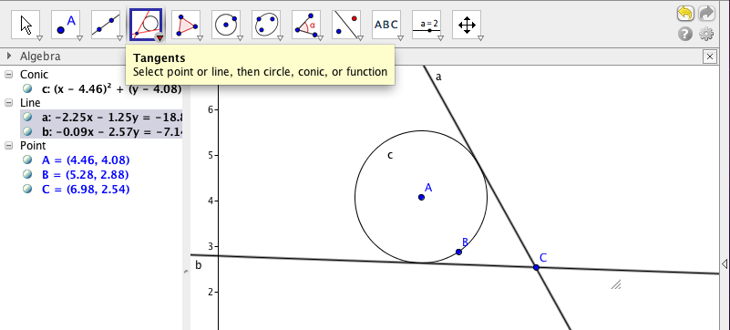

5. We have to now find the lines of intersection.
Click on the Point Tool. Next click on Intersect.
First click on the circle and line a, then click on the circle and line b.
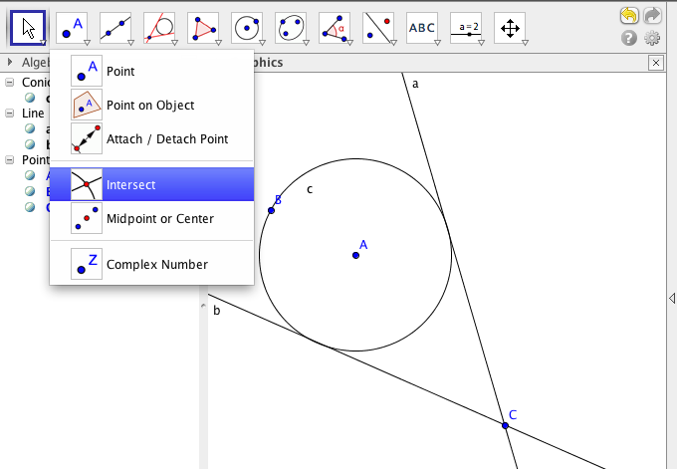

6. What does that give us? And how can we use them to find the exterior angle?

__________________________________________________________________________

__________________________________________________________________________

7. Now that we have the points of intersection, we need to create segments. Segments will help us create equal length with our points and our circle.
Click on the Line Tool, and select Segment.
Create two segments from point D to A and point A to E.

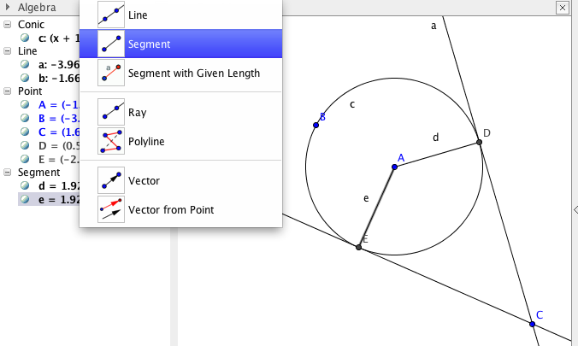

8. Now we will measure the arcs. Click the Angle Tool, and find the angle DCE, CEA, EAD, DAE and ADC. You have to make sure you go in that order because if you do not, it will give you the exterior angles.

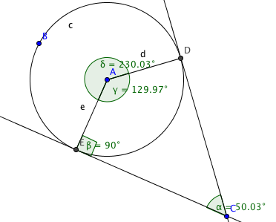
What relationship does DCE and DAE have?

__________________________________________________________________________

__________________________________________________________________________

Looking at the relationship between the DCE and DEA, what can we conclude?

__________________________________________________________________________

__________________________________________________________________________

9. There is a formula we can use to obtain the measure of the exterior angle.
Create a textbox under the Text Tool to show this formula.

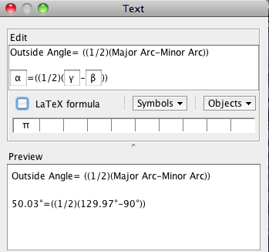

Worksheet:
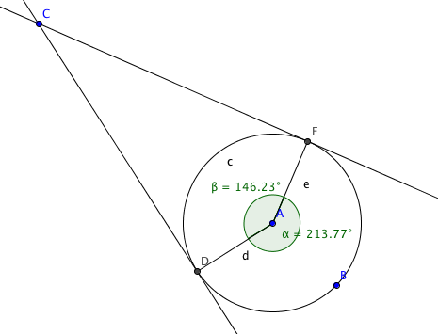
1. Find γ:

_________________________

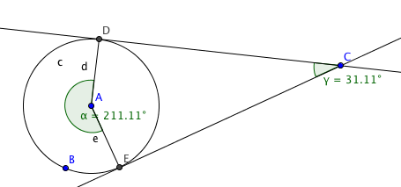
Find β:

____________________

